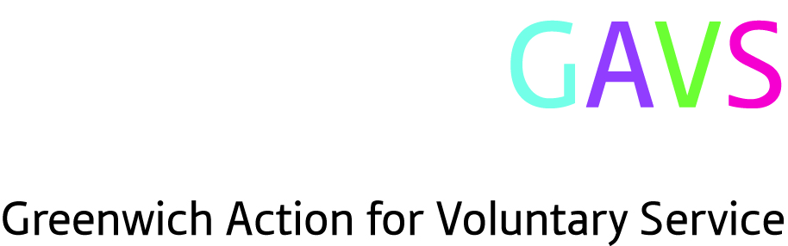

GAVS Monitoring Form

This form will be separated from your application form and filed separately. The information is for monitoring purposes only and will not play any part in the selection process. The form will only be used to monitor the effectiveness of GAVS’ Diversity Policies. It will be kept in accordance with requirements of the Data Protection Act 1998.

Ethnic Origin:

White:
White British
White Irish
Any other White background

Mixed:
White and Black Caribbean
White and Black African
White and Asian
Any other mixed background

Asian or Asian British:
Indian
Pakistani
Bangladeshi
Any other Asian background

Black or Black British:
Caribbean
African
Any other Black background

Other ethnic groups:
Chinese
Any other ethnic group

Gender:

Male/ Female * (*delete as appropriate)

Disability:

Do you consider yourself to have any disabilities? Yes/No *

Media:

Where did you see or hear of this vacancy?

Thank you for completing this form

