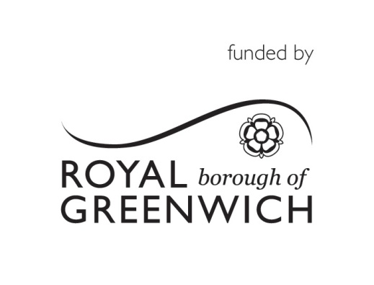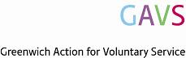

RBG Community Cohesion Small Grants Fund: Monitoring Form
Please fill in the monitoring form below and then send it to naomi.goldberg@gavs within one month of completing this project. You may wish to discuss the how you will complete this form with your Development Officer at GAVS for some initial feedback before submitting. Tel 020 8309 8231 or email info@gavs.biz. Before completing this form please read the monitoring Form Guidance Notes.
About your group

Name of your Group:
Main contact:
Position in group:
Email address of main contact:
Main telephone number:

About the project
Project Title
Project Summary. A copy of the description made in your application will be placed below:
Which Priority did this project address?
Supporting new and emerging communities to access services
Reducing social isolation
Supporting individuals with specific disabilities e.g. autism, spina bifida etc
Supporting the community and individuals to understand their rights under the Care Act

Please what you delivered and anything that went particularly well

Tell us about any challenges or problems you encountered when delivering the project

How many of the target groups set out below took part in your project this can be an approximation

Target group | Number taking part
Older people
Minority ethnic groups
Low income groups
People with various disabilities
People with mental health problems
People with a specific disabilities (please specify)
People with learning disabilities
The whole community
Other (please specify)

The Local Community

Which of these Outcomes did your Project contribute towards?(Please tick all that apply).

People have an increased sense of self-worth
Reduced experience of inequality
Adults with disabilities and other vulnerable adults are more independent
Adults with disabilities and other vulnerable adults have increased physical and mental well-being
More adults with disabilities and other vulnerable adults are full and equal members of and contributors to society
Fewer adults with disabilities and other vulnerable adults are socially isolated or excluded.
Please describe below how you know that the project contributed towards the outcomes you have ticked

Project Budget
Total Project Budget | £
Total Grant Provided by RBG | £
How much you spent? | £
Breakdown of spend:
Item |  | Cost £

Monitoring:
Please attach any monitoring information that you have and mark below the information you are providing
Data taken from sign up sheets/attendance lists
Data/information taken from surveys/interviews
Before and after case studies
Photos/video
Copies of receipts for any single item of expenditure over £500
Other (please specify)

Please send your completed monitoring form and additional monitoring information to Naomi.Goldberg@gavs.biz within one month of completing the project

